DEPARTMENT OF PROFESSIONAL EDUCATION
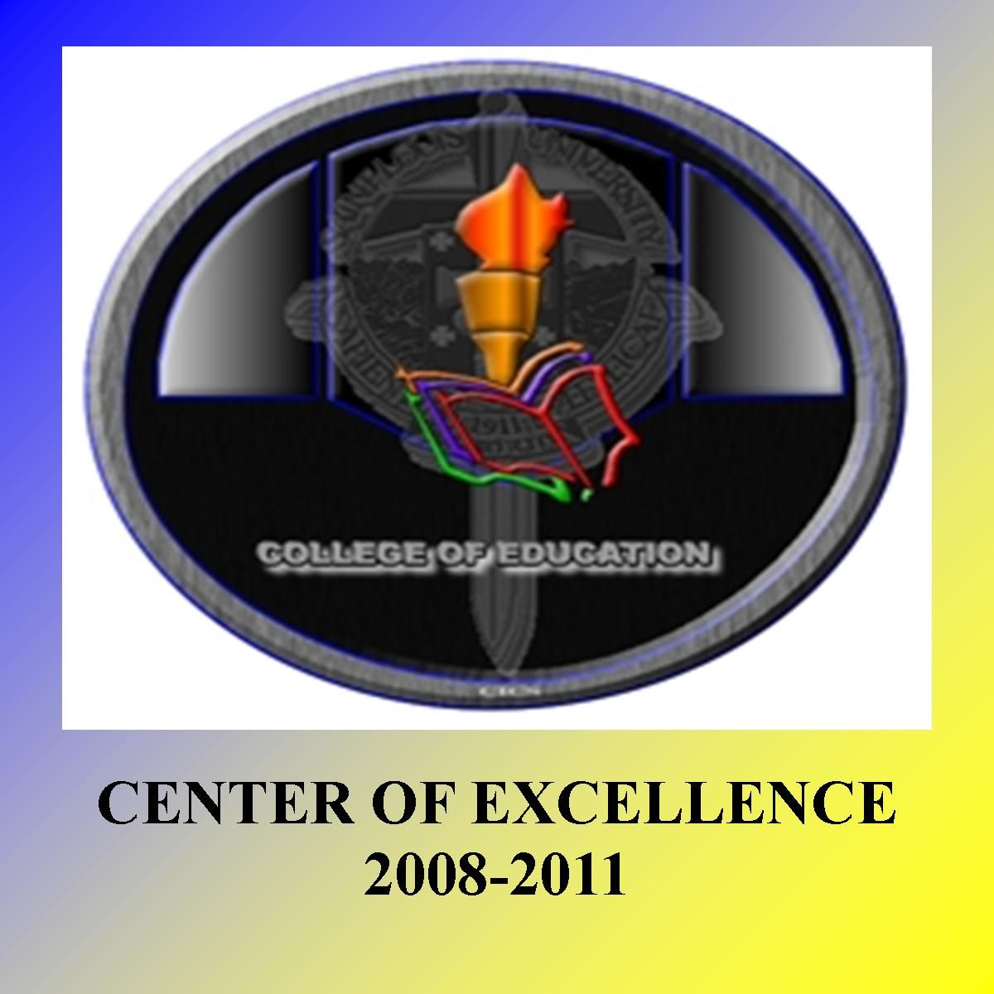
College of Education, Saint Louis University, Baguio City

NEWSLETTER RUBRIC
CATEGORY | EXCELLENT | VERY GOOD | GOOD | FAIR
ATTRACTIVENESS | The student’s works has attractive design. | The students work has well organized information. | Students design and organize the improvement. | The students design the work is confusing to the reader.
SPELLING | No spelling errors remain after one person other than the typist reads and correct the works. | No more than 1 spelling error remains after one person other than the reads typist. | No more than 3 spelling error remain after one person other than the reads typist. | Several spelling errors remain.
PICTURES | Pictures go well with the text and there is a good mix of text. | Pictures go well with the text, but there are so many that they distract from the text. | Pictures go well with the text, but there are too few. | Pictures go well with the text, with the accompanying text or appear to be randomly chosen.
COLOR | Color palette used is pleasing, coordinated and relevant to the subject without using too many colors. | The color palette used is relevant to the subject without using too many colors. | The color palette used is not relevant to the subject. | Uncoordinated and too many colors are used.
MESSAGE AND AUDIENCE | Message and audience are very well defined and the purpose of the newsletter is very clear. | Message and audience are defined but the purpose of the newsletter is not clear. | Message and audience are not defined or the purpose of the newsletter is not clear. | Message and audience are not defined the news letter does not seem to have a purpose
Prepared by:
VILLARUZ, Wilfredo E. Jr.
BsEd- MAPEH 3

